Ivanti VPN Multi-Factor Authentication
with FIDO Security Key
Originator: | Jeff Rhey |  | Effective Date: | September 07, 2024
Manager Approval: | Sender De La Roca |  | Original Date: | September 07, 2024
 |  |  | Revision Date: | January 15,2025
PURPOSE
State purpose
PROCEDURES

Ivanti VPN Multi-Factor Authentication

with FIDO Security Key

IMPORTANT MESSAGE: When using the FIDO Security Key for MFA, you will be additionally prompted for your BEST username and password when accessing the Jumpboxes or the File Share links. This additional prompt does not occur when using the Octopus Authenticator App for MFA.

NOTE: An invitation email will contain a link that will only be available for 96 hours from when the email was sent. If the time has expired or you encounter any issues during the enrollment process, contact TISPlatform-ERP@lacoe.edu to request a new invitation email with a new code.

Enroll your FIDO Security Key

Requirements (all the below):
- Email invitation
- Windows Laptop/Desktop
- FIDO Security Key

- Look out for an email from OctopusAuth@lacoe.edu with the subject line “Welcome to FIDO Authenticator” (see sample below).
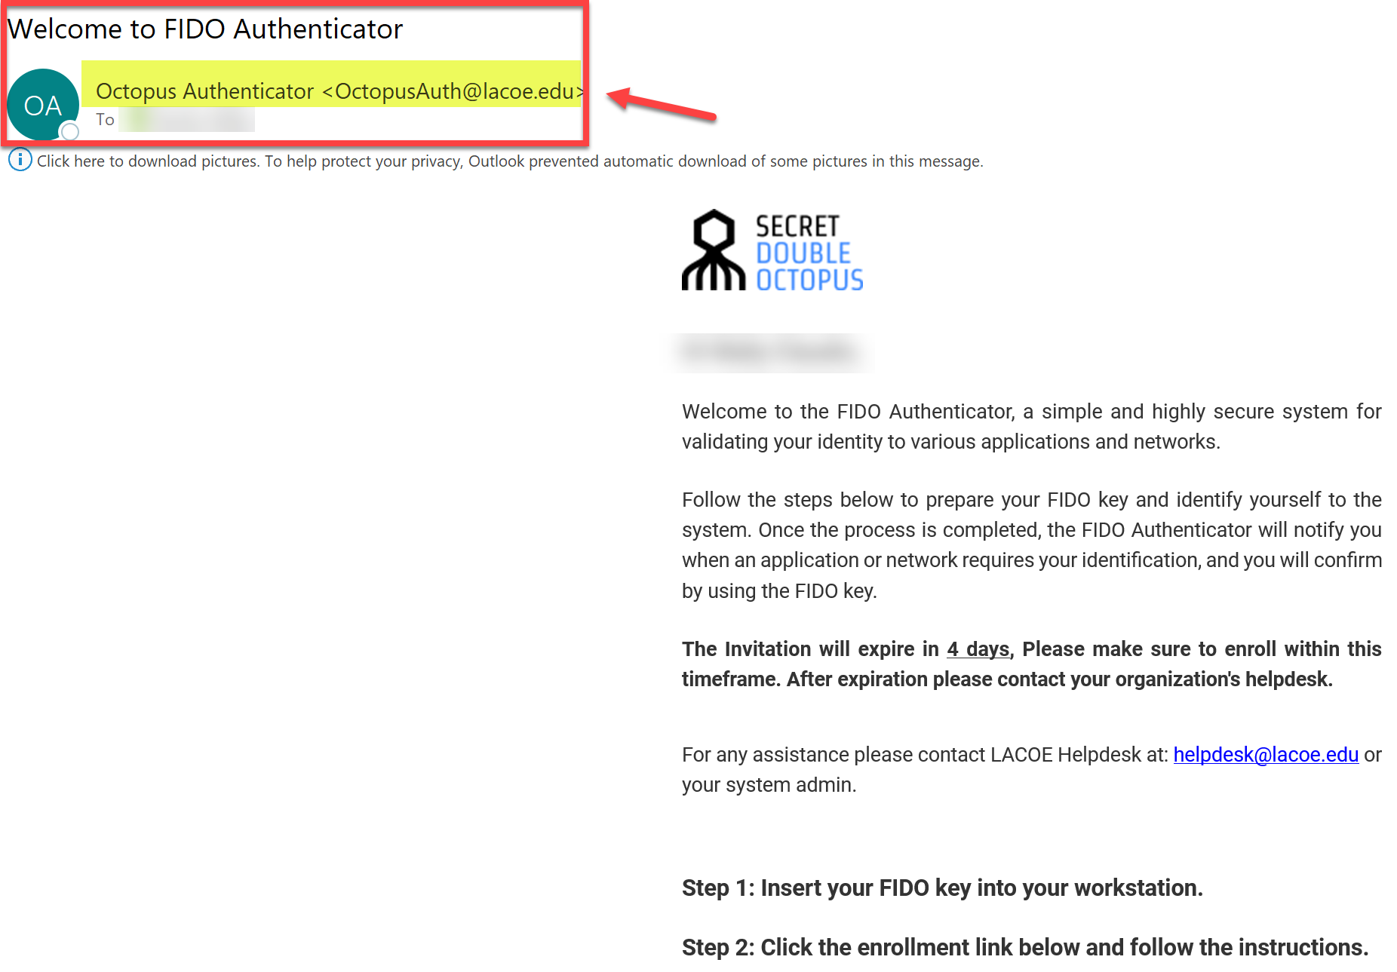

- Follow the steps in the email
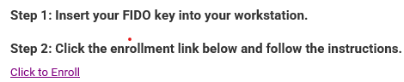
- Your web browser should open up the FIDO Authenticator Registration page
- Click Register

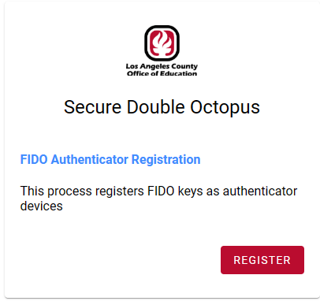
- A Create a passkey window should pop up

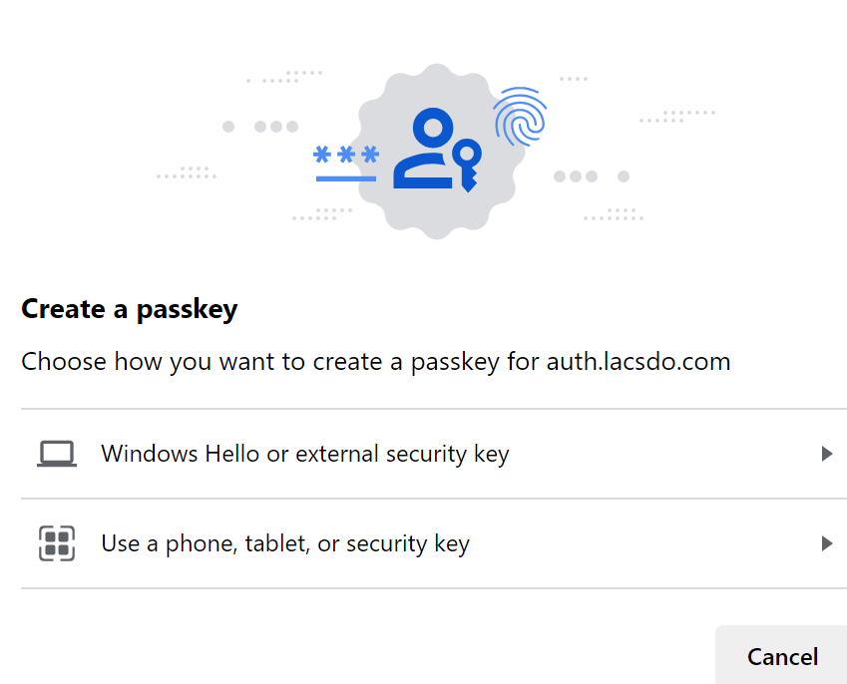

- Click on Windows Hello or external security Key
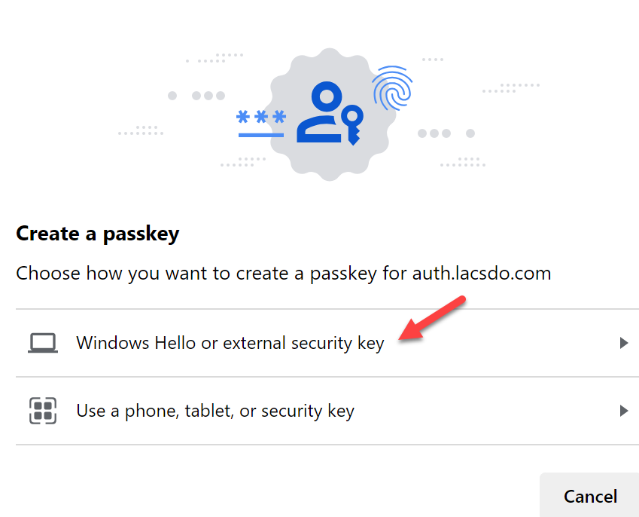

- A Windows Security dialog box pops up. Click ok.

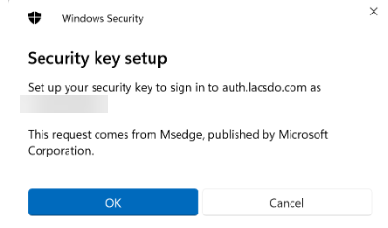

- On the Windows Security dialog box, Click OK

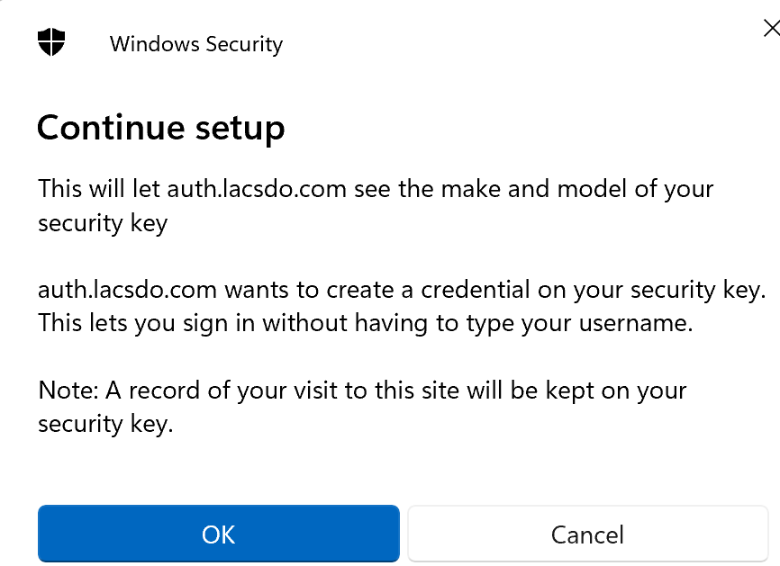

- Next, you will be prompt to create a PIN Code to use with your FIDO key. Enter your PIN Code then Click OK

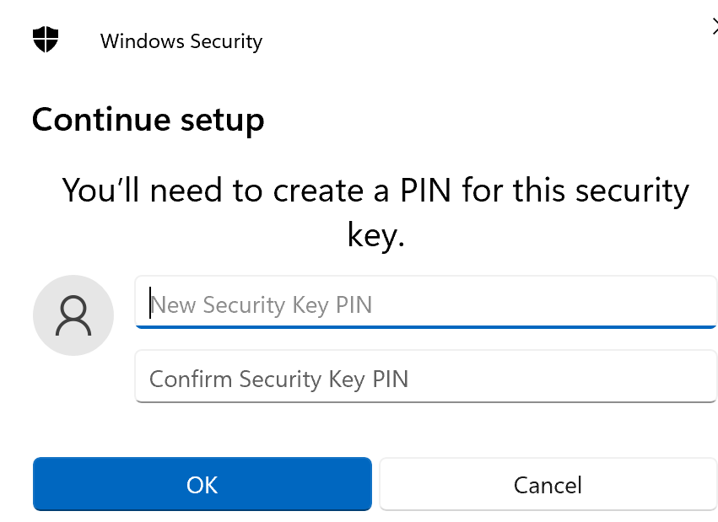

- If you haven’t plugged the FIDO key into your computer yet, you will be prompted to do so. At this step touch the FIDO security key.
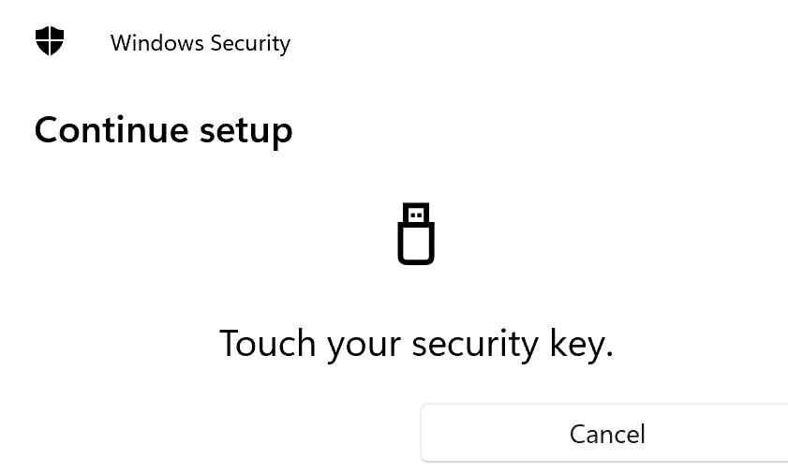

- Once your device has been successfully enrolled you will see this Congratulations message below.
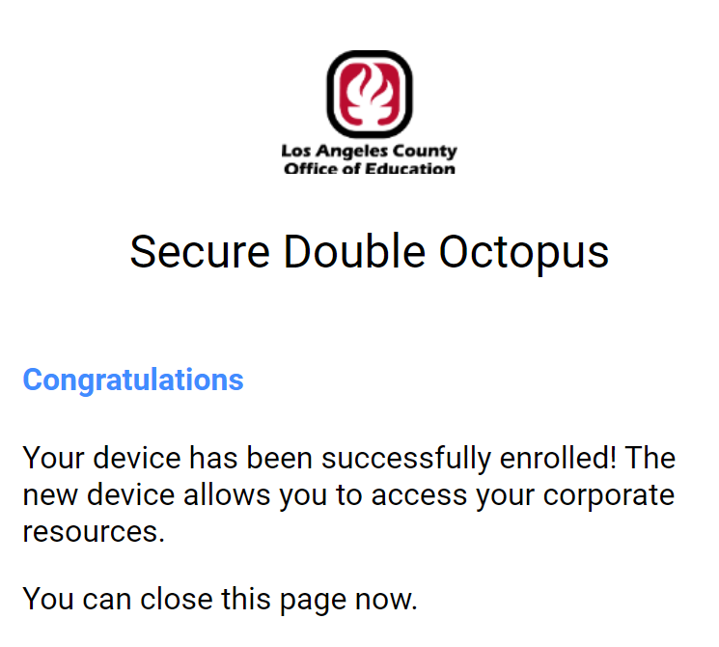

- If you do not see this page or any other issues occur, contact TISPlatform-ERP@lacoe.edu to send another invitation code to your email.
Login to Ivanti VPN using the FIDO Security key

- Navigate to Ivanti VPN Login page for a FIDO Security key
  - Primary Downey FIDO: TBD
  - Secondary DR FIDO: https://dr1-vpn.best.lacoe.edu/bestsdosaml
- Enter your BEST Support Specialist Account (Ivanti VPN) Username and click Next
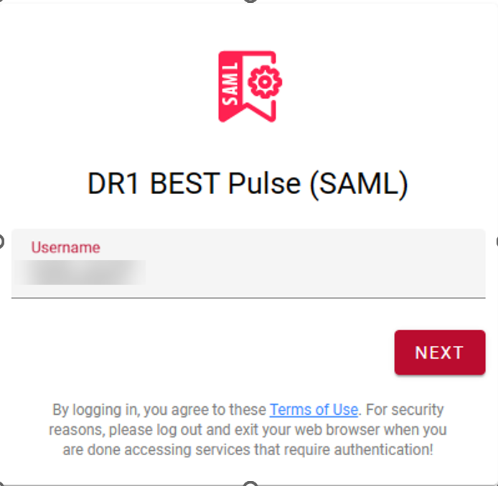

- Change the Authenticator Type to FIDO Authenticator, enter your password, and click Login
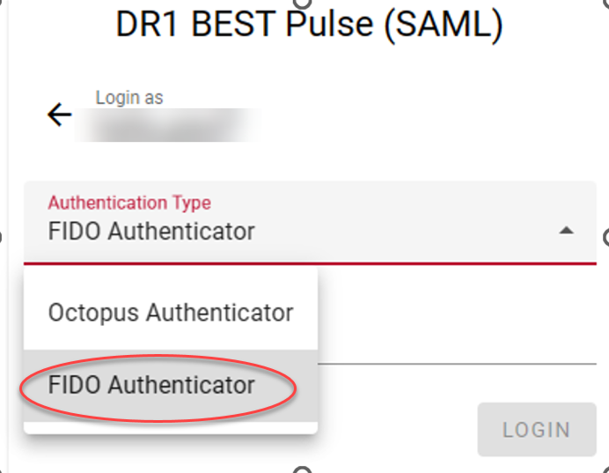

- Next, Choose a passkey for auth.lacsdo.com and click on Windows Hello or external security key.
- You should now be prompted to enter your FIDO security key PIN code. If you have already done so, skip to the next step.
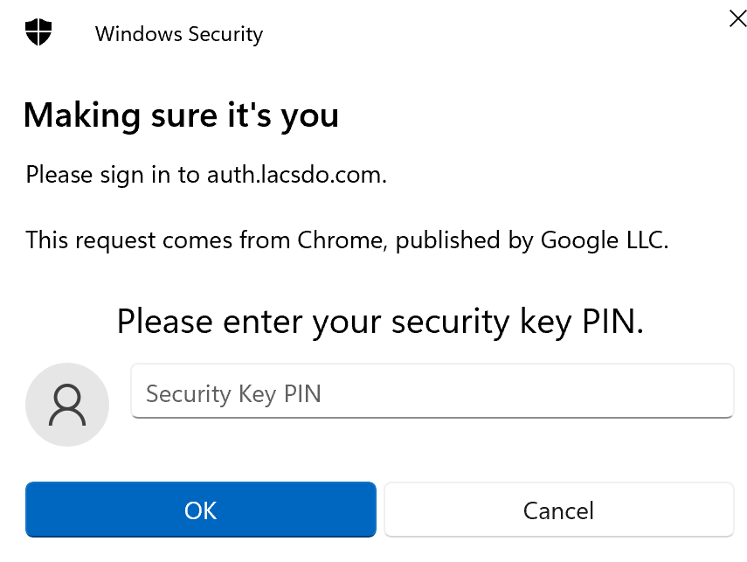

- You will be prompted to touch your FIDO security key. This may be different depending on the model of FIDO key you have.
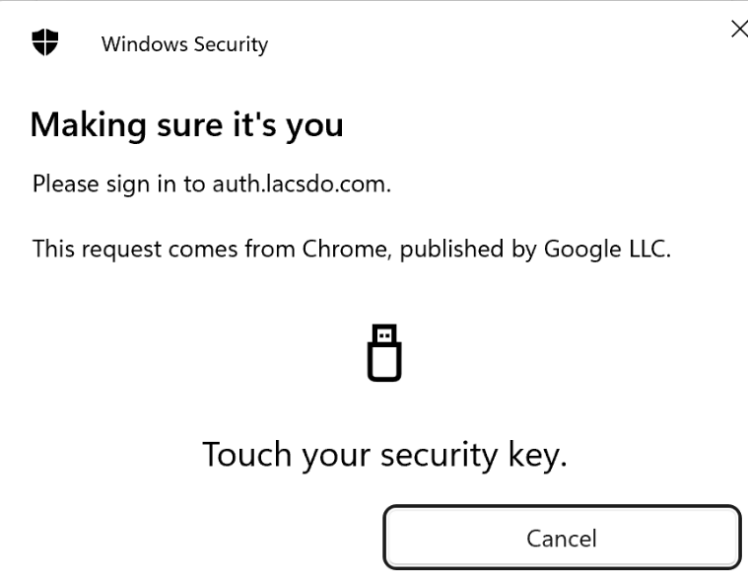

- Once you have successfully logged in with your FIDO key, you should be redirected to the familiar Ivanti VPN page with access to the BEST environment.

IMPORTANT MESSAGE: When using the FIDO Security Key for MFA, you will be additionally prompted for your BEST username and password when accessing the Jumpboxes or the File Share links. This additional prompt does not occur when using the Octopus Authenticator App for MFA.

